PROBLEM STATEMENT:

Medicines are managed effectively by the combination of lifestyle changes. The predicted results can be used to prevent the several future diseases and reduce the cost for the other expenses. The overall objective of my work is to predict accurately with few attributes considered from the primary basis for accurate results. We can take more input values but we need to predict in the way faster and more efficient. This practice leads to unwanted biases, errors and excessive medical costs which affect the quality of service to the patient

DATASET:

The Dataset is available publicly on the Kaggle website The classification goal to predict the prescribed drug to the new patient. The dataset provides the patients information It includes over 200 records and 6 attributes. Each attribute is a potential risk factor.

2.1 Data Dictionary

|  |  |  |  |
| --- | --- | --- | --- |
| # | Attributes | Description | Values |
| 1 | Age | Patient age in years | Continuous values |
| 2 | Sex | Sex of the Patient | 0=Female  1=Male |
| 3 | BP | Blood pressure level | 0=LOW  1=NORMAL  2=HIGH |
| 4 | Cholesterol | Serum cholesterol level | 0=Normal  1=High |
| 5 | NA_to_K | The prescribed level | Continuous values |
| 6 | Drug | The prescribed Drug | Continuous values |

Data Description:

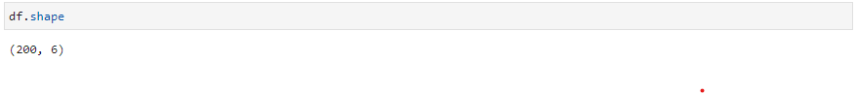

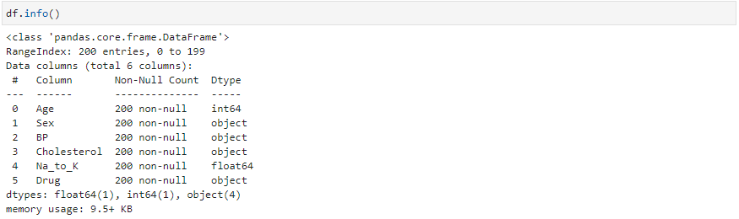

2.2 Data source Links

<https://www.kaggle.com/datasets/pablomgomez21/drugs-a-b-c-x-y-for-decision-trees>

2.3 Task

To perform Decision tree and predict the prescribed medicine for the same illness.

ALGORITHMS/ MODEL:

Decision Tree Classifier

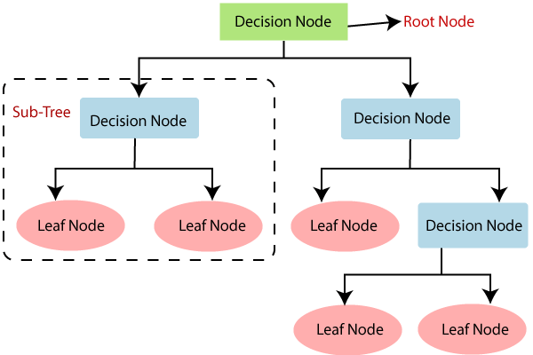

Figure1: Decision tree classifier model (Source: <https://www.javatpoint.com/machine-learning-decision-tree-classification-algorithm>)

Decision tree is a graphical representation for getting all the possible solutions to a problem/decision based on given conditions

Decision tree is a sample of multiclass classifier, and you can use the training part of the dataset to build a decision tree, and then use it to predict the class of a unknown.

For example

* To predict whether game starts based on climate condition
* To predict whether the game wins based on the previous stats

Decision Tree is a Supervised learning techniquethat can be used for both classification and Regression problems, but mostly it is preferred for solving Classification problems. It is a tree-structured classifier, whereinternal nodes represent the features of a dataset, branches represent the decision rules and each leaf node represents the outcome.